Picture Bingo

Method 1
- Cut out the definitions to produce tiles
- Give out the Picture Card and the definition tiles
- When an object is called out, cover the picture with the definition

Method 2
- Only give out the definitions as a bingo card
- When an object is called out, put a line through the definition
This may help: https://www.computerhope.com/jargon.htm

Definitions
Volatile memory that the computer can access faster than CD, HD or SSID | Supplies components in a computer with power | An output device that displays video images and text | Handheld hardware input device that controls a cursor in a GUI and can move and select text, icons, files, and folders. | A coin cell battery used to power the memory that stores the system time and date and also the system hardware settings for the computer.

Picture Bingo Cards
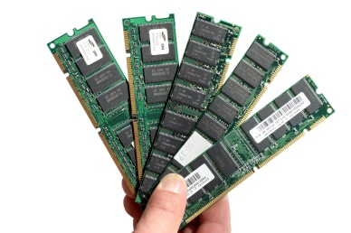 | 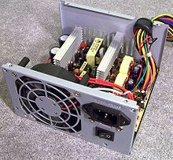 |  | 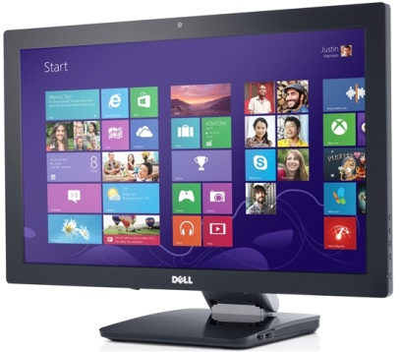
 |  | 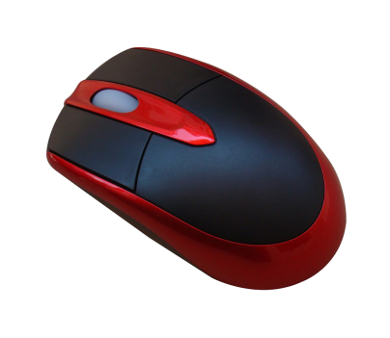 |  | 